Eventi
Use Case Specification

Submitted to:

Asst. Prof. Ma. Rowena C. Solamo
Faculty Member
Department of Computer Science
College of Engineering
University of the Philippines, Diliman

Submitted by:
Dimaano, Aaron Diego I.
Lopez, Matthew S.
Torres, Jacob Angelo V.

In partial fulfillment of academic requirements
for the course
CS 191 Software Engineering I
of the
1st Semester, AY 2015-2016
Unique Reference:
The documents are stored in https://github.com/Tom-2013-06417/CS191-192_Event_Sharing/tree/master/02-Requirements%20Engineering.
Link to this document: https://github.com/Tom-2013-06417/CS191-192_Event_Sharing/blob/master/02-Requirements%20Engineering/10.0%20-%20View%20event%20statistics.pdf.

Document Purpose:
The purpose of this document is to exhaust the step-by-step process of the Use Cases in every scenario possible.

Target Audience:
To our project client and adviser, our fellow 191 classmates, and our future selves when they need to refer back to this document.

Revision Control:

Revision Date | Person Responsible | Version  Number | Modification
09/18/15 | Dimaano, Diego  Lopez, Matthew  Torres, Jacob | 1.0 | Initial Document

Use-Case Name: View statistics

Description: A feature which allows you to see how well your events have been doing. This functionality aims to provide you with statistical data which you can use to improve your future events. This is also great for people who need to quantify the objectives for their events.

Preconditions: There is an internet connection to the Eventi server and a device with browsing capabilities. A registered user that has permission to operate an organization must be currently logged into the site.

Flow of Events:

Scenario Name | Description
Scenario 1 (Basic Flow)  User wants to view an event’s statistics | 1. Registered User opens the Organization's profile  2. Registered User can now operate the Organization  3. Registered User can select an event of the Organization  4. Registered User can view the event’s statistics

Activity Diagram of the Flow of Events:

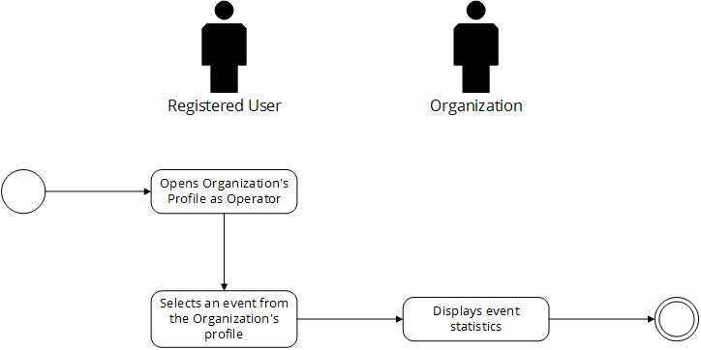

Post-conditions: Successful: The statistic has successfully loaded and they are shown.
Failed: The website did not load. There are no statistics.

Special Requirements: NONE

